SIMATS ENGINEERING
ASSESSMENT TOOL 1

COURSE NAME: INTERNET PROGRAMMING
COURSE CODE: CSA43

COURSE OUTCOME COVERED

CO 3: Implement dynamic web applications by utilizing DOM-based client-side scripting and employing Java Servlets for server-side request processing and response handling. (L3)

Assessment Tool : Scenario-Based Assessment

Weightage: 40%
Dr.V.Parthipan
Code of Conduct:

I K.Lahari (192325118) (Name / Reg No) certify that this submission is my original work and that I have adhered to the guidelines specified for this assessment.
I understand that any violation of academic integrity rules will result in disciplinary action.

Signature of the student: K. Lahari

QUESTIONS: Total Marks: 30

Question 1: Suppose that a college wants to develop an online student registration system where students submit their details through a web form, and the data is processed using a Java Servlet. Explain the architecture of a servlet-based application. Design and implement a servlet to handle form data using both GET and POST methods. Describe the servlet life cycle (init, service, destroy) and justify which method is more appropriate for handling sensitive data.

(a) Architecture of a Servlet-Based Application
A servlet is a Java class that runs inside a servlet container such as Apache Tomcat and generates dynamic responses to HTTP requests (request–response model):
- Client and container: the browser sends an HTTP request (GET or POST) to a URL such as /college/register. The servlet container (Tomcat) accepts it, creates the HttpServletRequest and HttpServletResponse objects, and manages the servlet’s life cycle, threads and sessions.
- URL mapping: the @WebServlet annotation or web.xml tells the container which servlet handles the URL.
- Servlet: reads the form data with request.getParameter(), applies the logic (validation, saving to a database through JDBC) and writes the HTML response, which the container returns to the browser.
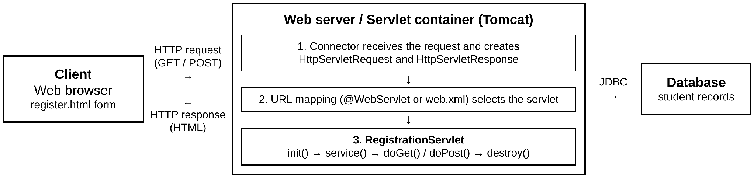
Figure 1: Architecture of a servlet-based application

(b) Registration Form
The form collects the student’s details and sends them to the servlet. A drop-down lets the tester choose GET or POST so that both methods can be demonstrated with the same form.
<!DOCTYPE html>
<html lang="en">
<head>
<meta charset="UTF-8">
<meta name="viewport" content="width=device-width, initial-scale=1.0">
<title>Student Registration</title>
<!-- CSS styling omitted -->
</head>
<body>
<h2>Online Student Registration</h2>
<label for="method">Submit using</label>
<select id="method">
<option value="post">POST</option>
<option value="get">GET</option>
</select>
<form id="regForm" action="register" method="post">
<label for="studentName">Full Name</label>
<input type="text" id="studentName" name="studentName" required>
<label for="email">Email</label>
<input type="email" id="email" name="email" required>
<label for="phone">Phone</label>
<input type="text" id="phone" name="phone">
<label for="course">Course</label>
<select id="course" name="course" required>
<option value="">-- Select --</option>
<option>B.Sc. Computer Science</option>
<option>B.Com. Commerce</option>
</select>
<label for="password">Password</label>
<input type="password" id="password" name="password" required>
<button type="submit">Register</button>
</form>
<script>
document.getElementById("method").addEventListener("change", (e) => {
document.getElementById("regForm").method = e.target.value;
});
</script>
</body>
</html>

(c) Servlet Implementation (GET and POST)
(In all Java listings the import statements are omitted to save space.) The servlet overrides doGet() and doPost(). Both call one common method, handle(), so the same processing is applied whichever method the browser uses. It checks required fields, escapes output (prevents cross-site scripting) and never prints the password.
package registration;
@WebServlet(urlPatterns = "/register", initParams =
@WebInitParam(name = "college", value = "Greenfield College"))
public class RegistrationServlet extends HttpServlet {
private String college;
private final AtomicInteger requestCount = new AtomicInteger();
@Override
public void init(ServletConfig config) throws ServletException {
super.init(config); // called once
college = config.getInitParameter("college");
log("RegistrationServlet initialised");
}
@Override
protected void doGet(HttpServletRequest req, HttpServletResponse resp)
throws ServletException, IOException {
handle(req, resp, "GET");
}
@Override
protected void doPost(HttpServletRequest req,
HttpServletResponse resp)
throws ServletException, IOException {
req.setCharacterEncoding("UTF-8");
handle(req, resp, "POST");
}
private void handle(HttpServletRequest req, HttpServletResponse resp,
String method) throws IOException {
resp.setContentType("text/html;charset=UTF-8");
PrintWriter out = resp.getWriter();
String name = value(req, "studentName");
String email = value(req, "email");
String phone = value(req, "phone");
String course = value(req, "course");
String password = value(req, "password");
if (name.isEmpty() || email.isEmpty() || course.isEmpty()) {
resp.setStatus(HttpServletResponse.SC_BAD_REQUEST);
out.println("<h3>Error: name, email, course required.</h3>");
return;
}
int n = requestCount.incrementAndGet();
String query = req.getQueryString();
out.println("<html><body style='font-family:Arial;margin:30px'>");
out.println("<h2>" + esc(college) + " - Registration Received</h2>");
out.println("<p>Request method: <b>" + method + "</b></p>");
out.println("<p>Name: " + esc(name) + "<br>Email: " + esc(email));
out.println("<br>Phone: " + esc(phone)
+ "<br>Course: " + esc(course));
out.println("<br>Password: received (" + password.length()
+ " characters, not displayed)</p>");
out.println("<p style='word-break:break-all'>Data visible in URL: <b>"
+ (query == null ? "none" : esc(query)) + "</b></p>");
out.println("<p>Requests handled since init(): " + n + "</p>");
out.println("</body></html>");
}
@Override
public void destroy() {
log("RegistrationServlet destroyed"); // called once
}
private static String value(HttpServletRequest req, String key) {
String v = req.getParameter(key);
return v == null ? "" : v.trim();
}
private static String esc(String s) { // prevents XSS
return s.replace("&", "&amp;").replace("<", "&lt;")
.replace(">", "&gt;").replace("\"", "&quot;");
}
}

(d) Output
Actual output from running this code on Tomcat 10.1, submitting the form once with POST and once with GET.
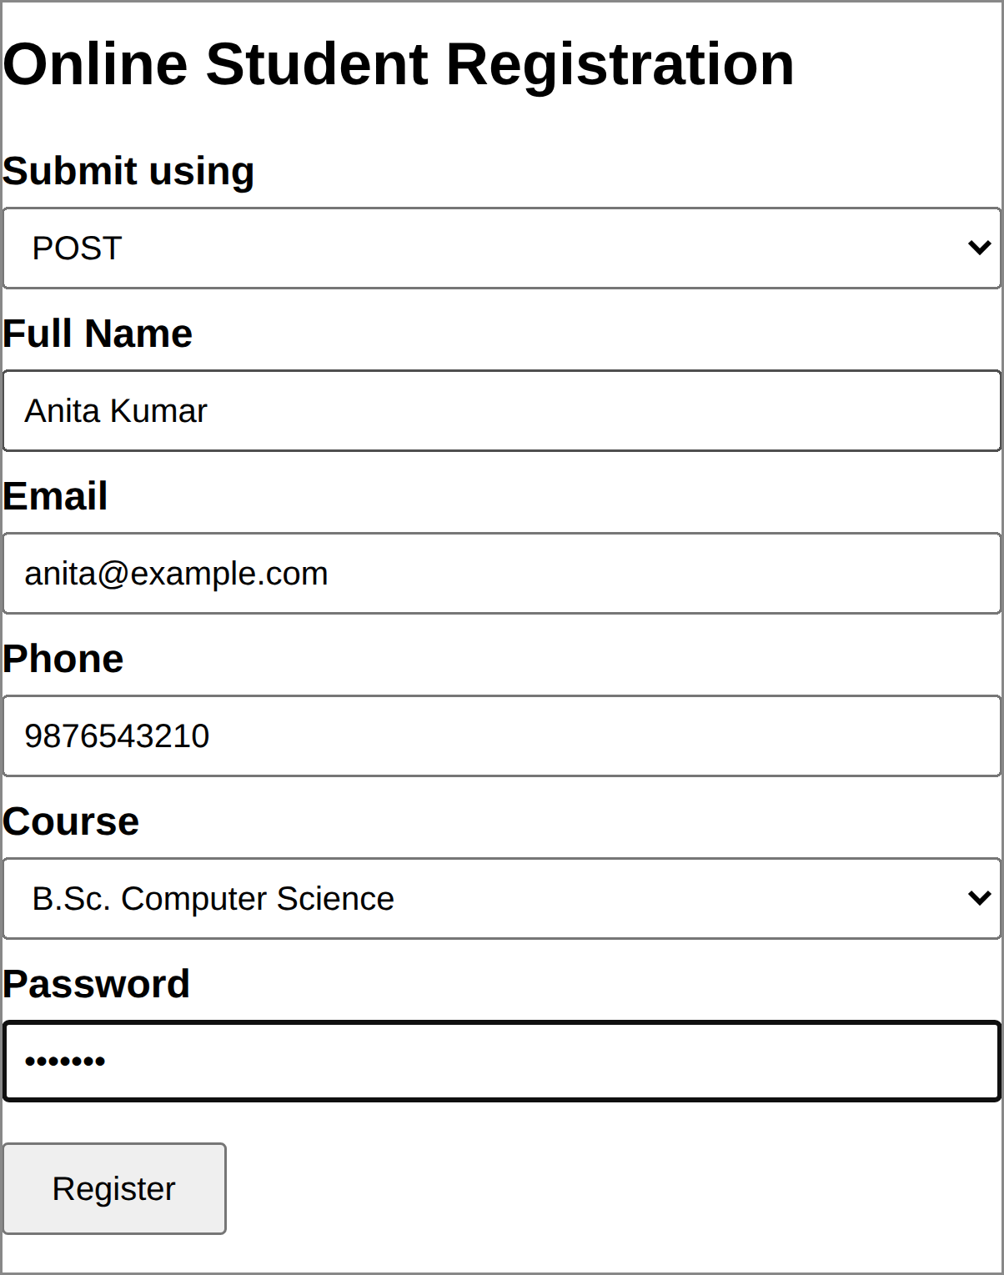  Figure 2: Registration form (POST selected) | 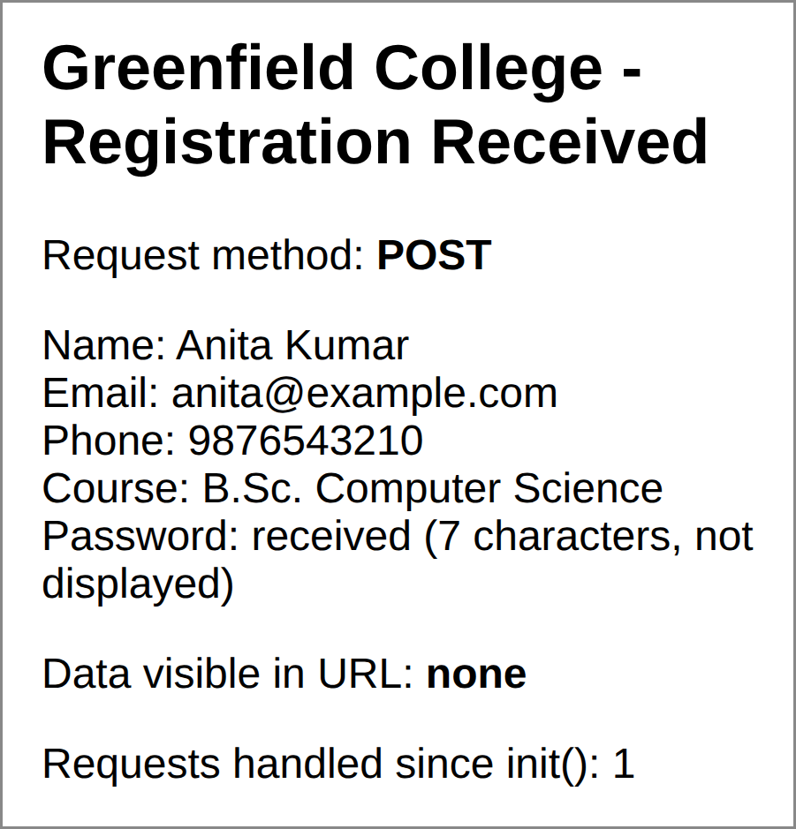  Figure 3: Result of the POST request

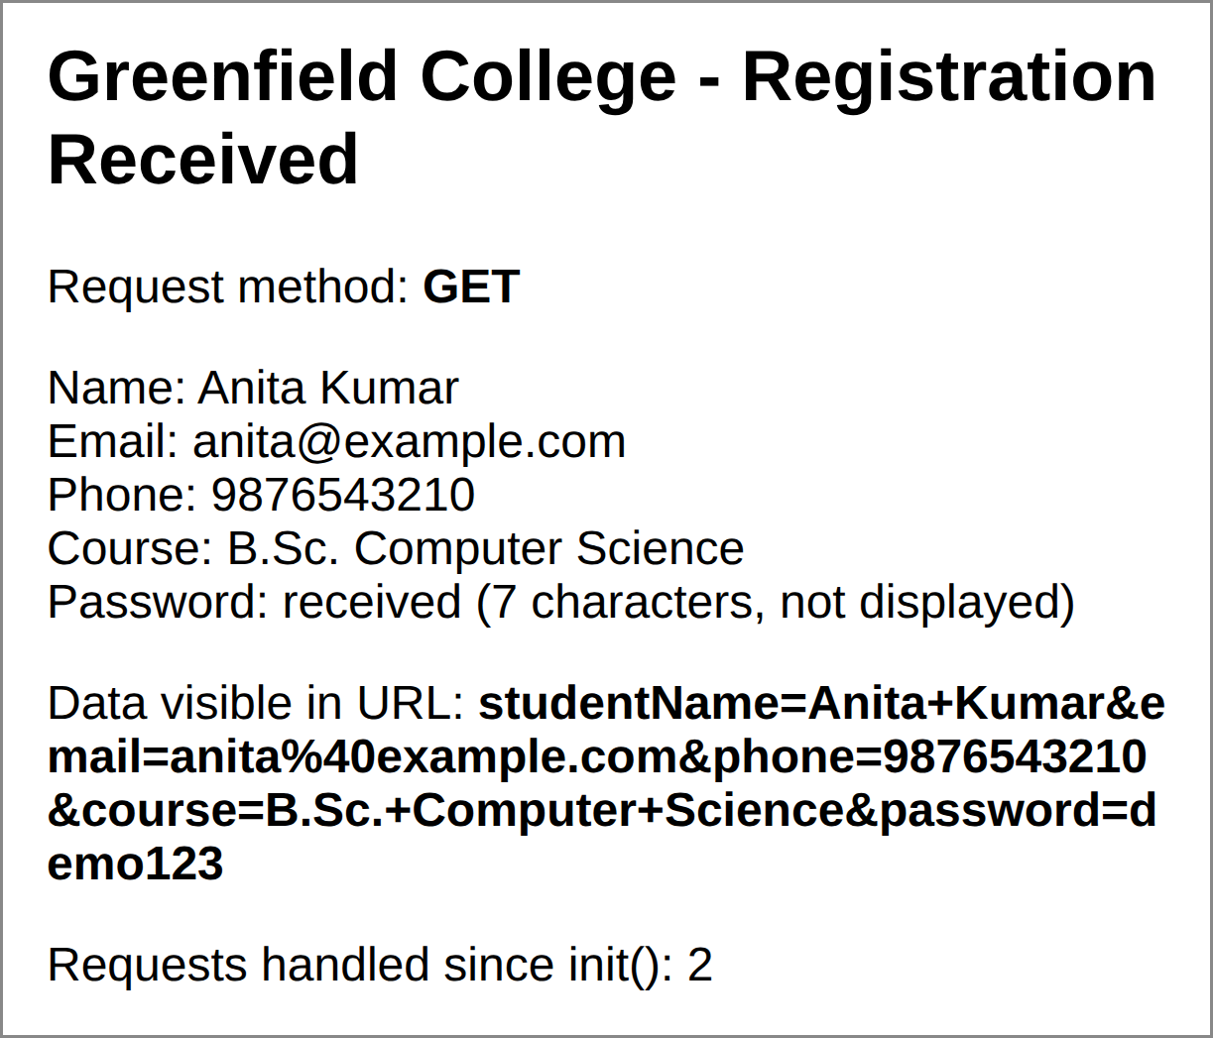
Figure 4: Result of the GET request: the data, including the password, appears in the URL
Explanation: with POST, the result page shows “Data visible in URL: none” because the values travel in the request body. With GET, the same values are appended to the URL as a query string (studentName=Anita+Kumar&…&password=demo123), so anyone who sees the address bar, browser history or server log can read them. The counter (2) shows that one servlet object handled both requests.

(e) Servlet Life Cycle
The container controls the life cycle. One servlet object serves all requests, each on its own thread.
- Loading: the container loads the class and creates one instance, on the first request or at start-up.
- init(ServletConfig): called once for one-time work such as reading init-parameters or opening resources. Here it reads the college parameter and writes a log entry.
- service(request, response): called for every request. HttpServlet.service() checks the HTTP method and calls doGet() or doPost(). Many threads run it at once, so instance data must be thread-safe (AtomicInteger is used).
- destroy(): called once when the application is undeployed or the server stops; used to release resources such as database connections.
Log line written by init(): INFO: registration.RegistrationServlet: RegistrationServlet initialised

(f) GET versus POST and Handling of Sensitive Data
Basis | GET | POST
Data location | Appended to the URL as a query string | Sent in the HTTP request body
Visibility | Visible in the address bar, browser history, bookmarks, server logs and the Referer header | Not shown in the URL or history
Typical use | Searching, filtering, reading data | Registration, login, payments, updating data

Justification: POST is more appropriate for sensitive data such as passwords and personal details. The data stays out of the URL, so it does not leak through browser history, bookmarks, shared links, server logs or the Referer header, as Figure 4 shows; POST is also the correct method for requests that create data and has no URL length limit. POST alone is not encryption: the data must also be sent over HTTPS, passwords stored as salted hashes, and forms protected with CSRF tokens.
Conclusion: the container maps each request to a servlet and manages its life cycle; using POST (with HTTPS) keeps students’ data secure.

Question 2: Suppose that a website requires users to log in and maintain their session across multiple pages after authentication. Design a session management system using HttpSession and Cookies in Servlets. Explain how session tracking works in web applications and compare session-based tracking with cookies.

(a) How Session Tracking Works
HTTP is a stateless protocol: each request is independent, and the server does not remember who sent the previous one. A web application therefore needs session tracking to recognise that a series of requests comes from the same user. The usual techniques are:
- Cookies: small data stored by the browser and sent back with every request to the same site.
- URL rewriting: the session id is added to every link (;jsessionid=…) with response.encodeURL(); used when cookies are disabled.
- HttpSession: the servlet API’s session object; data stays on the server and only the session id travels in a cookie (or URL).
The tracking process with HttpSession is:
- At login the servlet calls request.getSession(true); the container creates a session object on the server with a unique random id.
- The container sends the id to the browser as Set-Cookie: JSESSIONID=….
- On every later request the browser returns the cookie and the container finds the matching session; servlets use getAttribute() and setAttribute() on it.
- The session ends on logout (invalidate()) or after the inactivity timeout (here 10 minutes).

(b) Design of the Session Management System
LoginServlet (/login) checks the credentials, creates the session and sets the optional Remember-me cookie; AuthFilter redirects visitors without a session away from /dashboard and /profile; PageServlet shows the protected pages with session details and a visit counter; LogoutServlet invalidates the session; Html is a helper that escapes text (XSS).

(c) Implementation
The credentials are hard-coded only for the demonstration; a real system checks a database and salted password hashes. Html.java (not listed) has one method, esc(), which replaces & < > and quotes.
LoginServlet.java
package auth;
@WebServlet("/login")
public class LoginServlet extends HttpServlet {
// Demo credentials only. A real system checks a database and
// compares a salted password hash.
private static final String USER = "student";
private static final String PASS = "pass123";
@Override
protected void doGet(HttpServletRequest req, HttpServletResponse resp)
throws ServletException, IOException {
String remembered = "";
Cookie[] cookies = req.getCookies(); // read cookies
if (cookies != null) {
for (Cookie c : cookies) {
if (c.getName().equals("rememberedUser")) {
remembered = c.getValue();
}
}
}
resp.setContentType("text/html;charset=UTF-8");
String msg = req.getParameter("msg");
resp.getWriter().println(
"<html><body style='font-family:Arial;margin:30px'>"
+ "<h2>Student Portal Login</h2>"
+ (msg == null ? "" : "<p style='color:#c00'>"
+ Html.esc(msg) + "</p>")
+ "<form method='post' action='login'>"
+ "Username:<br><input name='username' value='"
+ Html.esc(remembered) + "'><br><br>"
+ "Password:<br><input type='password' name='password'><br><br>"
+ "<label><input type='checkbox' name='remember'> "
+ "Remember my username</label><br><br>"
+ "<button>Log in</button></form></body></html>");
}
@Override
protected void doPost(HttpServletRequest req, HttpServletResponse resp)
throws ServletException, IOException {
String user = req.getParameter("username");
String pass = req.getParameter("password");
if (USER.equals(user) && PASS.equals(pass)) {
HttpSession old = req.getSession(false);
if (old != null) old.invalidate(); // avoid session fixation
HttpSession session = req.getSession(true); // new session
session.setAttribute("user", user);
session.setAttribute("visits", 0);
session.setMaxInactiveInterval(10 * 60); // 10 minutes
if ("on".equals(req.getParameter("remember"))) {
Cookie c = new Cookie("rememberedUser", user);
c.setMaxAge(7 * 24 * 60 * 60); // 7 days
c.setHttpOnly(true); // hide from JS
c.setPath(req.getContextPath());
resp.addCookie(c); // never store
} // the password
resp.sendRedirect(req.getContextPath() + "/dashboard");
} else {
resp.sendRedirect(req.getContextPath()
+ "/login?msg=Invalid+username+or+password");
}
}
}

AuthFilter.java
package auth;
@WebFilter(urlPatterns = {"/dashboard", "/profile"})
public class AuthFilter implements Filter {
@Override
public void doFilter(ServletRequest request, ServletResponse response,
FilterChain chain)
throws IOException, ServletException {
HttpServletRequest req = (HttpServletRequest) request;
HttpServletResponse resp = (HttpServletResponse) response;
HttpSession session = req.getSession(false); // do not create one
if (session == null || session.getAttribute("user") == null) {
resp.sendRedirect(req.getContextPath()
+ "/login?msg=Please+log+in+first");
return; // block the page
}
chain.doFilter(request, response); // allow the page
}
}

PageServlet.java
package auth;
@WebServlet({"/dashboard", "/profile"})
public class PageServlet extends HttpServlet {
@Override
protected void doGet(HttpServletRequest req, HttpServletResponse resp)
throws ServletException, IOException {
HttpSession session = req.getSession(false); // set by the filter
int visits = (Integer) session.getAttribute("visits") + 1;
session.setAttribute("visits", visits);
String page = req.getServletPath().substring(1); // dashboard
String base = req.getContextPath(); // or profile
resp.setContentType("text/html;charset=UTF-8");
resp.getWriter().println(
"<html><body style='font-family:Arial;margin:30px'>"
+ "<h2>" + Html.esc(page.toUpperCase()) + " page</h2>"
+ "<p>Welcome, <b>"
+ Html.esc((String) session.getAttribute("user")) + "</b></p>"
+ "<p>Session ID: " + session.getId().substring(0, 8) + "...<br>"
+ "Created: " + new Date(session.getCreationTime()) + "<br>"
+ "Timeout: " + session.getMaxInactiveInterval() + " seconds<br>"
+ "Pages viewed in this session: " + visits + "</p>"
+ "<a href='" + base + "/dashboard'>Dashboard</a> | "
+ "<a href='" + base + "/profile'>Profile</a> | "
+ "<a href='" + base + "/logout'>Logout</a>"
+ "</body></html>");
}
}

LogoutServlet.java
package auth;
@WebServlet("/logout")
public class LogoutServlet extends HttpServlet {
@Override
protected void doGet(HttpServletRequest req, HttpServletResponse resp)
throws ServletException, IOException {
HttpSession session = req.getSession(false);
if (session != null) {
session.invalidate(); // remove all session data
}
resp.sendRedirect(req.getContextPath()
+ "/login?msg=You+have+been+logged+out");
}
}

(d) Output
Actual output on Tomcat 10.1 (context path /site): login with Remember-me ticked, dashboard, profile page, and an attempt to open a protected page without logging in.
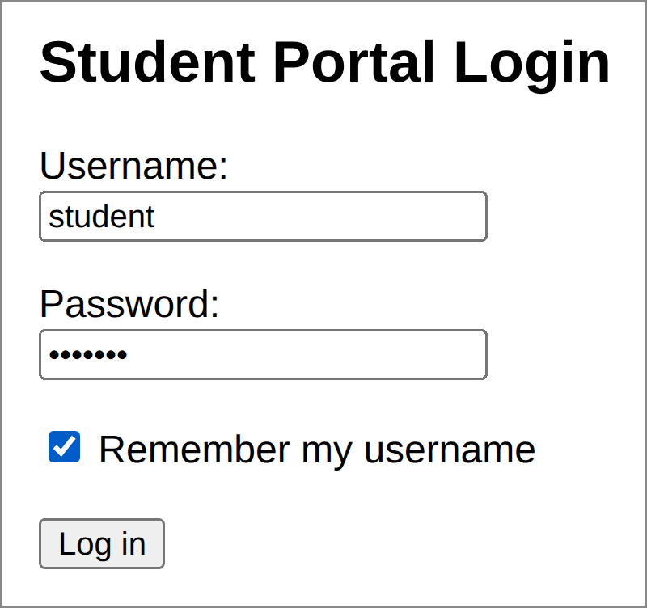  Figure 5: Login page | 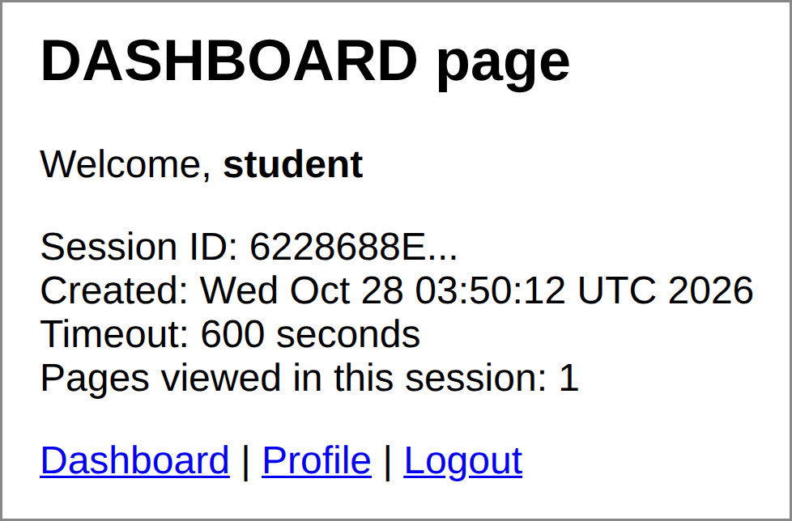  Figure 6: Dashboard after login (1 page viewed)

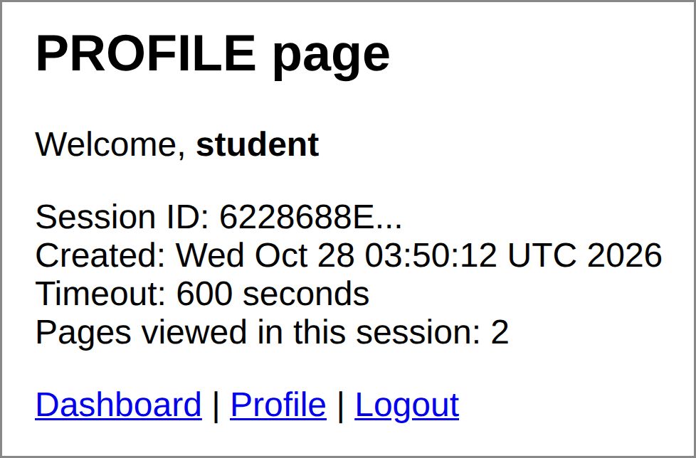  Figure 7: Profile page: same session, 2 pages viewed | 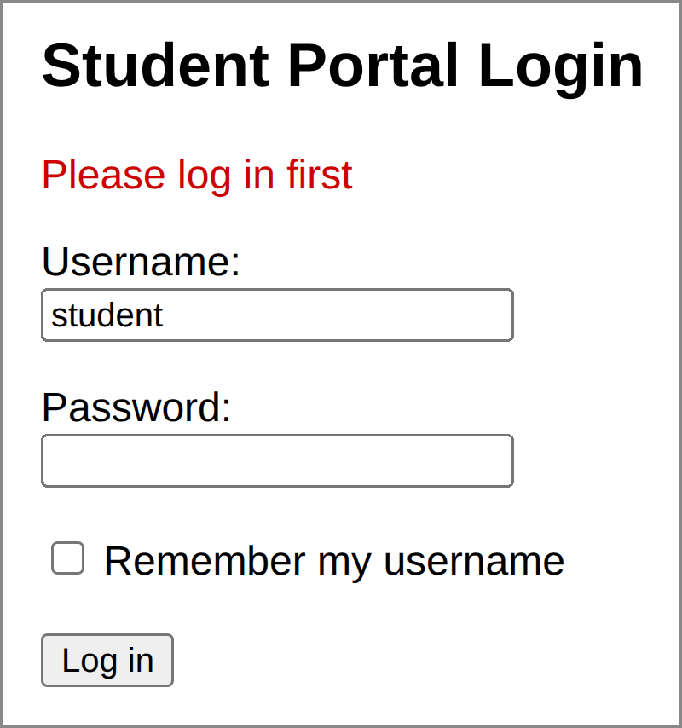  Figure 8: Opening /dashboard without logging in

The login response captured with curl shows the session cookie and the Remember-me cookie (long line wrapped):
HTTP/1.1 302
Set-Cookie: JSESSIONID=AE03F7A4972DDC9D790DA19DF31B4F3A; Path=/site;
HttpOnly
Set-Cookie: rememberedUser=student; Max-Age=604800;
Expires=Mon, 02 Nov 2026 04:55:32 GMT; Path=/site; HttpOnly
Location: /site/dashboard

Opening /dashboard with the cookie returned HTTP 200; without it the filter returned HTTP 302 to /login (Figure 8).

(e) Explanation of the Code
- Session creation: at login the old session is invalidated and getSession(true) creates a new id (prevents session fixation); setAttribute("user", user) marks the browser as authenticated and setMaxInactiveInterval(600) sets a 10-minute timeout.
- Session data: PageServlet increments the visits attribute on every page, so the counter goes from 1 to 2 in Figures 6 and 7 without a database.
- Cookie: rememberedUser holds only the username (never the password), lasts seven days and is HttpOnly; the login form reads it with request.getCookies().
- Protection and logout: AuthFilter uses getSession(false) to redirect visitors without a session; LogoutServlet calls invalidate().

(f) Session-Based Tracking versus Cookies
Basis | Session (HttpSession) | Cookies
Where data is stored | On the server; the browser holds only the session id | In the user’s browser
Security | More secure: the real data is never exposed to the client | Less secure: the user can read, edit or delete them; must not hold secrets
Data type and size | Any Java object | Text only, about 4 KB per cookie
Best use | Login state, shopping cart | Preferences, Remember-me username

Conclusion: the two are complementary: HttpSession keeps private data on the server and a cookie carries the session id (mark it HttpOnly, Secure and SameSite, and use HTTPS). With a filter, they keep users logged in across pages with controlled access and timeout.

Question 3: Suppose that an e-commerce platform needs to store and retrieve product details from a database using a Java-based web application. Design a JDBC-based application to connect to a database, insert product data, and retrieve it using SQL queries. Explain the JDBC architecture and describe the steps involved in database connectivity along with proper exception handling.

(a) JDBC Architecture
Java Database Connectivity (JDBC) is a standard API (package java.sql) that lets Java programs connect to relational databases and run SQL through a common set of interfaces. Its layers are:
- Java application: console program, servlet or DAO class.
- JDBC API: Connection, Statement, PreparedStatement, ResultSet and SQLException.
- DriverManager: chooses the registered driver that accepts the JDBC URL.
- JDBC driver and database: a vendor library (MySQL Connector/J, Oracle, PostgreSQL, H2) translates JDBC calls into the database’s protocol; Type 4 (pure Java) drivers are the most common.
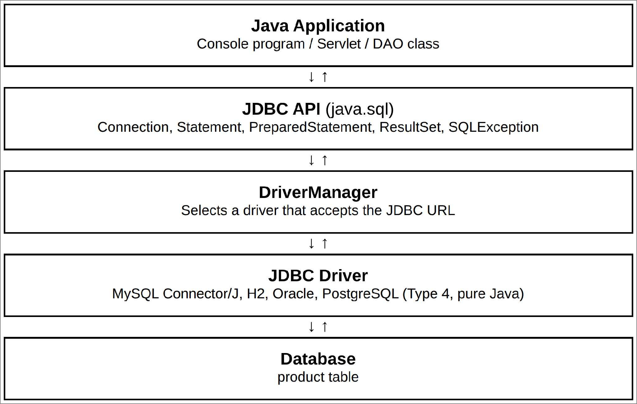
Figure 9: JDBC architecture

(b) Steps in Database Connectivity
- Add the driver: put the driver jar (mysql-connector-j or h2.jar) on the classpath or in WEB-INF/lib; since JDBC 4.0 it registers itself, so Class.forName() is not needed.
- Open a connection: DriverManager.getConnection(url, user, password), e.g. jdbc:mysql://localhost:3306/shopdb or jdbc:h2:./productdb (used here).
- Create a statement: Statement for fixed SQL, PreparedStatement for SQL with ? parameters (safe from SQL injection).
- Execute and process: executeUpdate() for INSERT, UPDATE, DELETE, CREATE; executeQuery() for SELECT, then loop with while (rs.next()) and read columns with getInt(), getString(), etc.
- Close resources: try-with-resources closes them automatically, even after an exception.

(c) Implementation
The code follows the Data Access Object (DAO) pattern: all SQL is placed in ProductDAO, so a console program or a servlet can reuse it. The programs are in package shop.
Product.java (a record holding one product row; Java 16 or later)
package shop;
public record Product(int id, String name, String category,
BigDecimal price, int stock) { }

ProductDAO.java
package shop;
public class ProductDAO {
private final String url, user, password;
public ProductDAO(String url, String user, String password) {
this.url = url;
this.user = user;
this.password = password;
}
// Open a connection (closed by try-with-resources in the callers)
private Connection connect() throws SQLException {
return DriverManager.getConnection(url, user, password);
}
public void createTable() throws SQLException {
try (Connection con = connect();
Statement st = con.createStatement()) {
st.executeUpdate("DROP TABLE IF EXISTS product"); // demo only
st.executeUpdate("CREATE TABLE product ("
+ "product_id INT AUTO_INCREMENT PRIMARY KEY, "
+ "name VARCHAR(100) NOT NULL UNIQUE, "
+ "category VARCHAR(50) NOT NULL, "
+ "price DECIMAL(10,2) NOT NULL, "
+ "stock INT NOT NULL)");
}
}
// INSERT rows (PreparedStatement batch) as one transaction
public void insertAll(List<Product> products) throws SQLException {
String sql = "INSERT INTO product (name, category, price, stock) "
+ "VALUES (?, ?, ?, ?)";
try (Connection con = connect()) {
con.setAutoCommit(false);
try (PreparedStatement ps = con.prepareStatement(sql)) {
for (Product p : products) {
ps.setString(1, p.name());
ps.setString(2, p.category());
ps.setBigDecimal(3, p.price());
ps.setInt(4, p.stock());
ps.addBatch();
}
ps.executeBatch();
con.commit();
} catch (SQLException e) {
con.rollback(); // undo partial inserts
throw e;
}
}
}
// SELECT all rows
public List<Product> findAll() throws SQLException {
return query("SELECT * FROM product ORDER BY product_id", null);
}
// SELECT with a WHERE condition
public List<Product> findByCategory(String category)
throws SQLException {
return query("SELECT * FROM product WHERE category = ? "
+ "ORDER BY price", category);
}
private List<Product> query(String sql, String param)
throws SQLException {
List<Product> list = new ArrayList<>();
try (Connection con = connect();
PreparedStatement ps = con.prepareStatement(sql)) {
if (param != null) ps.setString(1, param);
try (ResultSet rs = ps.executeQuery()) {
while (rs.next()) {
list.add(new Product(rs.getInt("product_id"),
rs.getString("name"), rs.getString("category"),
rs.getBigDecimal("price"), rs.getInt("stock")));
}
}
}
return list;
}
}

ProductApp.java (console program: insert, retrieve and show error handling)
package shop;
public class ProductApp {
static void print(List<Product> list) {
System.out.printf("%-4s %-22s %-12s %9s %5s%n",
"ID", "Name", "Category", "Price", "Stock");
for (Product p : list) {
System.out.printf("%-4d %-22s %-12s %9.2f %5d%n", p.id(),
p.name(), p.category(), p.price(), p.stock());
}
}
public static void main(String[] args) {
// For MySQL use: jdbc:mysql://localhost:3306/shopdb
ProductDAO dao = new ProductDAO("jdbc:h2:./productdb", "sa", "");
try {
dao.createTable();
dao.insertAll(List.of(
new Product(0, "Wireless Mouse", "Accessories",
new BigDecimal("599.00"), 50),
new Product(0, "USB-C Cable", "Accessories",
new BigDecimal("249.00"), 120),
new Product(0, "Laptop Backpack", "Bags",
new BigDecimal("1299.00"), 35),
new Product(0, "Bluetooth Speaker", "Audio",
new BigDecimal("1899.00"), 20)));
System.out.println("1) All products:");
print(dao.findAll());
System.out.println("\n2) Category = Accessories:");
print(dao.findByCategory("Accessories"));
System.out.println("\n3) Inserting a duplicate name:");
dao.insertAll(List.of(new Product(0, "Wireless Mouse",
"Accessories", new BigDecimal("650.00"), 10)));
} catch (SQLException e) {
if ("23505".equals(e.getSQLState())) { // unique violation
System.out.println("Duplicate name - row not inserted.");
} else {
System.out.println("Database error: " + e.getMessage());
}
System.out.println("SQLState = " + e.getSQLState()
+ ", ErrorCode = " + e.getErrorCode());
}
}
}

ProductServlet.java (the same DAO used in a web application)
package shop;
@WebServlet("/products")
public class ProductServlet extends HttpServlet {
private ProductDAO dao;
@Override
public void init() throws ServletException {
dao = new ProductDAO(
"jdbc:h2:mem:shopdb;DB_CLOSE_DELAY=-1", "sa", "");
try {
dao.createTable();
dao.insertAll(List.of(
new Product(0, "Wireless Mouse", "Accessories",
new BigDecimal("599.00"), 50),
new Product(0, "Laptop Backpack", "Bags",
new BigDecimal("1299.00"), 35)));
} catch (SQLException e) {
throw new ServletException("Database setup failed", e);
}
}
@Override
protected void doGet(HttpServletRequest req, HttpServletResponse resp)
throws ServletException, IOException {
resp.setContentType("text/html;charset=UTF-8");
PrintWriter out = resp.getWriter();
try {
out.println("<html><body style='font-family:Arial;margin:30px'>");
out.println("<h2>Product List</h2><table border='1' "
+ "cellpadding='8' style='border-collapse:collapse'>");
out.println("<tr><th>ID</th><th>Name</th><th>Category</th>"
+ "<th>Price (Rs.)</th><th>Stock</th></tr>");
for (Product p : dao.findAll()) {
out.println("<tr><td>" + p.id() + "</td><td>"
+ p.name().replace("<", "&lt;") + "</td><td>"
+ p.category() + "</td><td>" + p.price()
+ "</td><td>" + p.stock() + "</td></tr>");
}
out.println("</table></body></html>");
} catch (SQLException e) {
log("Query failed", e); // details go to the log
resp.sendError(500, "Unable to load products.");
}
}
}

(d) Output
Console output of ProductApp (actual run): SELECT of all rows, SELECT with WHERE, and the exception caught for a duplicate name.
1) All products:
ID Name Category Price Stock
1 Wireless Mouse Accessories 599.00 50
2 USB-C Cable Accessories 249.00 120
3 Laptop Backpack Bags 1299.00 35
4 Bluetooth Speaker Audio 1899.00 20

2) Category = Accessories:
ID Name Category Price Stock
2 USB-C Cable Accessories 249.00 120
1 Wireless Mouse Accessories 599.00 50

3) Inserting a duplicate name:
Duplicate name - row not inserted.
SQLState = 23505, ErrorCode = 23505

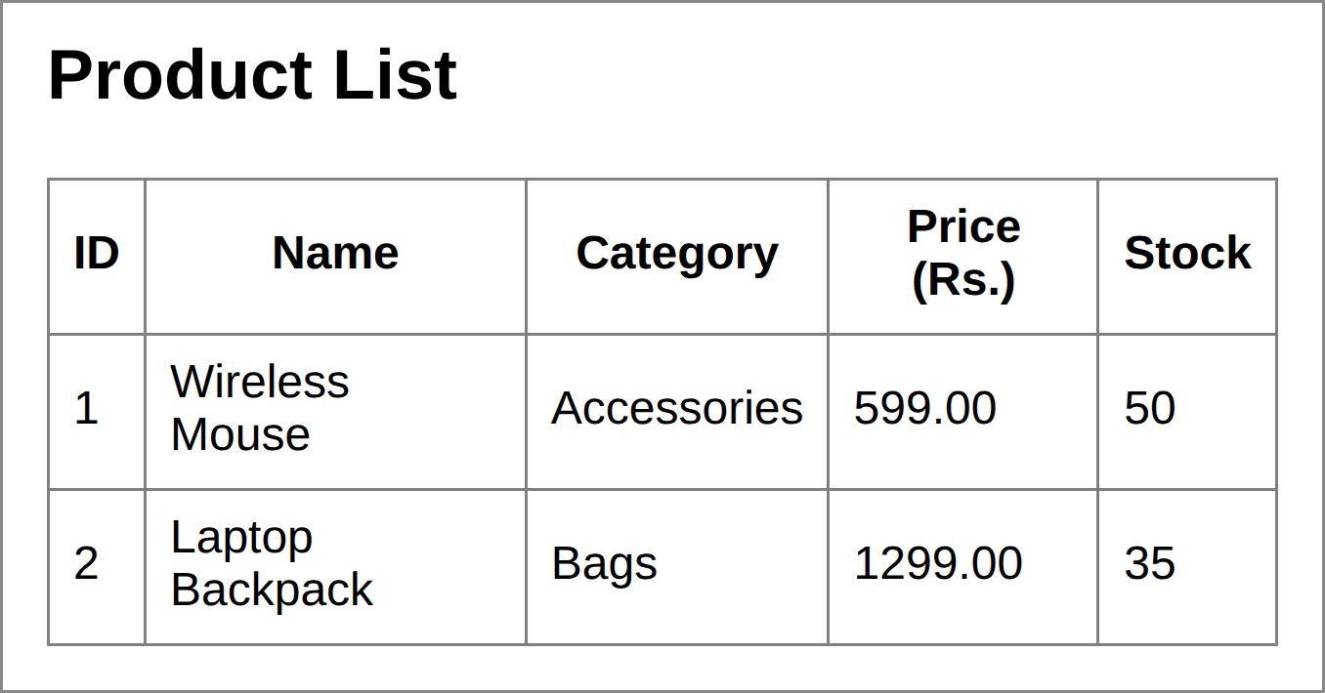
Figure 10: ProductServlet output in the browser (/shop/products): rows read from the database
Explanation: createTable() builds the table (name is UNIQUE); insertAll() inserts four rows in one transaction; findAll() and findByCategory() run SELECT queries and convert each ResultSet row into a Product. The UNIQUE constraint rejects the duplicate “Wireless Mouse” (SQLState 23505) without crashing the program.

(e) Exception Handling
JDBC methods throw the checked exception SQLException, so calls must be in try blocks. Good practices used here:
- try-with-resources closes the Connection, PreparedStatement and ResultSet automatically, so no connection is leaked.
- catch (SQLException e) reports getMessage(), getSQLState() (for example 23505 for a unique-key violation) and getErrorCode(); the code can react differently per error, as ProductApp does for duplicates.
- Transactions: setAutoCommit(false), commit(), and rollback() in the catch block keep the table consistent if any insert fails.
- Hide internal details: log the exception and show users a general message (HTTP 500); production systems also use a connection pool.
Conclusion: JDBC gives Java applications a uniform route to databases; PreparedStatement, ResultSet processing, resource closing and SQLException handling make it reliable.
Design a JDBC-based application to connect to a database, insert product data, and retrieve it using SQL queries. Explain the JDBC architecture and describe the steps involved in database connectivity along with proper exception handling.

